PICTURES TAKEN AT THE JIV TO NAOC, OBRIKOM 7T FLOW LINE, OBRIKOM FIELD, OMOKU, ONELGA, RIVERS STATE

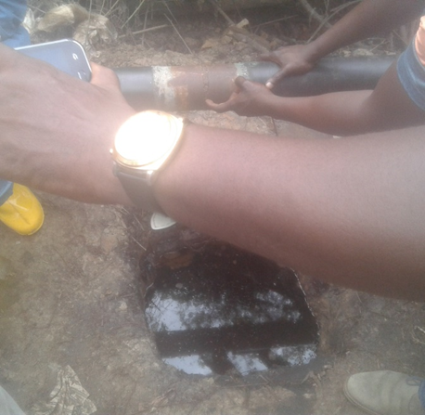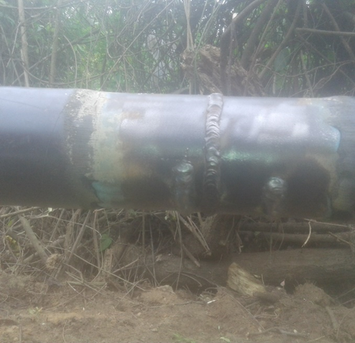
JIV Team observing the hacksaw cuts on the The line after repairs
line. Underneath is the ditch in which the
Condensate was contained

